**UBBER SUPPLY AND DEMAND GAP**

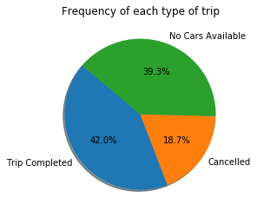

* There are only 42% of the trips (to and fro from the airport) are being completed.
* 58% of the trip are not being completed.
* Of which 39% are those in which there is no availability of cars and in 19% they got cancelled by the driver.

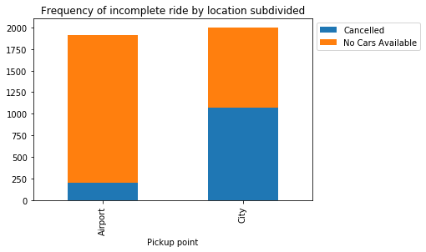

* There are more rides that are being not completed from city to airport(2003 rides) as compare to airport to city(1911 rides).
* In Airport to city ride problem the majority of the case is of ‘Non availability of the cars’.
* In City to Airport ride problem the majority of the case is of ‘Ride getting cancelled by the driver’.
* As less number of driver are willing to go to Airport therefore there are less number of rides available from airport.

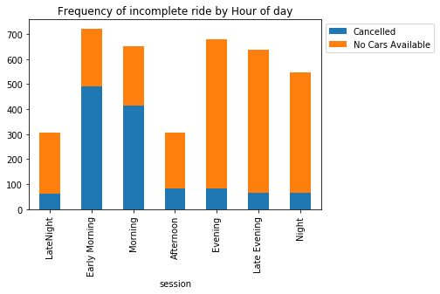

* Majority of the ride problem occurs in Early Morning, Evening and Late Evening.
* In Early Morning and Moring there are more chance of ride getting cancelled than not availability because Driver don’t want to got to Airport in the start of their jobs and wait their for long time for the next ride.
* In Evening and Night there are more chance of not availability of cars since most of the drivers finished their day ride and went home or are busy in the city.

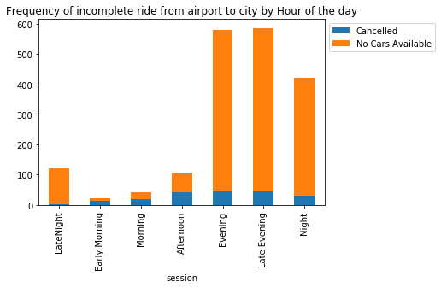

* From airport to city there are more ride problem in Evening and Late Evening and night.
* There are more problem of not availability of cars in Evening and Late Evening and Night since there are less not of flight in that time and less no of driver wants to go to airport therefore there are less availability of ride.

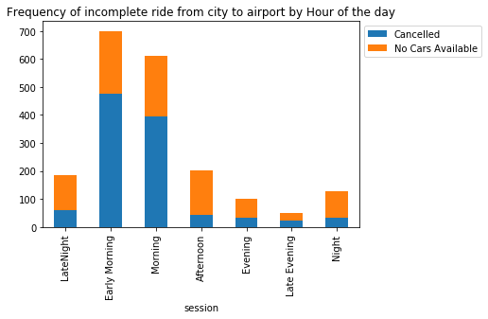

* From city to Airport most problem occurs while in Early Morning and Morning.
* And in Early Morning and Morning majority of Problems are where Driver Cancelled the ride.
* Late in Day Majority of problem is Non Availability of cars.

SOLUTION

* Ride Sharing is one of the option which could reduce the waiting time for the customers.
* Specific Uber station at airport so that he did not have to pay for the parking.
* Specific Uber station will also increase the chance of customer to get the service.
* Bonus for the driver for most airport to and fro trips.
* To cancel out wait time, offer concession in Uber commission to Driver, to motivate him.